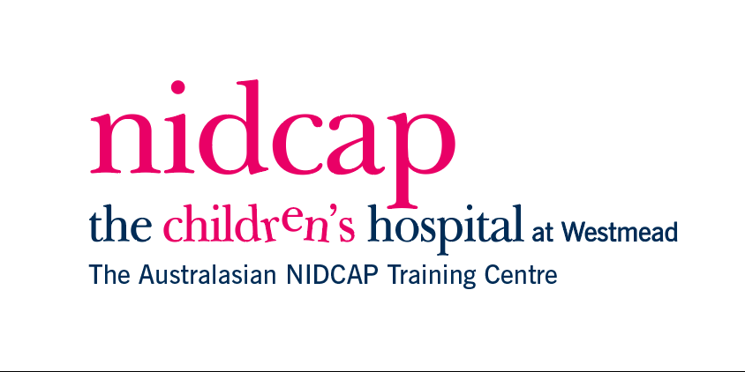

**Family and Infant Neurodevelopmental Education Program Level One**

**Rural Scholarship Program Application Form**

Applicants that meet the set criteria are invited to apply for the Rural Scholarship Fund. Please note you will be required to demonstrate your place of employment and provide a reference.

**Applicant Criteria:**

* Must reside in Australia
* Demonstrated employment as a health care professional in a neonatal unit
* Lives >100km from identified metropolitan centre in their state (i.e. Sydney, Canberra, Melbourne, Adelaide, Perth, Brisbane, Darwin)

**Personal Details**

Title: Surname: First name(s):

Postal address:

Postcode: Phone (daytime): Alternate Phone:

Email: Hospital/Employer:

Position:

Reference Name: Reference Position:

Reference email address: Reference Contact number:

*Please note an appropriate reference consists of your manager or a senior clinician in your unit of employment. References will be contacted to confirm your location of employment.*

Briefly outline your neonatal experience and how you would benefit from attending the FINE Program:

__________________________________________________________________________________________________________________________________________________________________________________________________________________________________________________________________________________________________________________________________________________________________________________________________________________________________________________________________

**FINE Level 1 Program Preference date for 2022:**

23 September (virtual) 17 November (Face to Face Sydney) 14 December (virtual)

*We will do our best to accommodate your preference*

Recipients of the Rural Scholarship are granted free registration to attend the FINE Level 1 program. They are required to self-fund travel and accommodation. Scholarship recipients are required to complete a written evaluation after attending the program.

**Successful applicants will be notified 8 weeks prior to the program. Submit your application to:** [**SCHN-NIDCAPAustralia@health.nsw.gov.au**](mailto:SCHN-NIDCAPAustralia@health.nsw.gov.au)