Kaye Spence AM scholarship Application
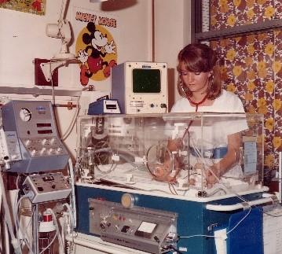
Application Prerequisites
- Must currently be employed as a neonatal nurse in an Australian Hospital
- Must have attended a neonatal conference/seminar in the past 2 years (evidence required of same)
Applicant name:
Role:
Hospital of Employment:
Years working in neonatal nursing:
Referee to support application (name, email address):
Individual completing the application:

Please provide an outline of how you or your colleague meet the selection criteria:
- recently published a paper, or have a publication history
- conducted original research
- led local quality improvement projects
- made a significant contribution to neonates or their care. This may be in the form of acknowledgement or recognition by parents, or through clinical practice or research. Please provide examples.
____________________________________________________________________________________________________________________________________________________________________________________________________________________________________________________________________________________________________________________________________________________________________________________________________________________________________________________________________________________________________________________________________________________________________________________________________________________________________________________________________________________________________________________________________________________________________________________________________________________________________________________________________________________________________________________________________________________________________________________________________________________________________________________________________________________________________________________________________________________________________________________________
Describe the qualities that make the nurse/you an asset to their/your workplace and to their/your nursing colleagues:
____________________________________________________________________________________________________________________________________________________________________________________________________________________________________________________________________________________________________________________________________________________________________________________________________________________________________________________________________________________________________________________________________________________________________________________________________________________________________________________________________________________________________________________________________________________________________________________________________________________________________________________________________________________________________________________________________________________________________________________________________________________________________________________________________________________________________________________________________________________________________________________________
Describe how you would utilise the scholarship if successful:
__________________________________________________________________________________________________________________________________________________________________________________________________________________________________________________________________________________________________________________________________________________________________________________________________________________________________________________________________________________________________________________________________________________________________________________________________________________________________________________________________________________________________________________________________________________________________
Additional information to support the application:
__________________________________________________________________________________________________________________________________________________________________________________________________________________________________________________________________________________________________________________________________________________________________________________________________________________________________________________________________________________________________________________________________________________________________________________________________________________________________________________________________________________________________________________________________________________________________
Submit by email: SCHN-SusanRyanSeminar@health.nsw.gov.au
The successful applicant will be announced at the annual Susan Ryan Neonatal Seminar.

